Best 25 Sites to Buy LinkedIn Accounts: Verified, PVA, & Aged
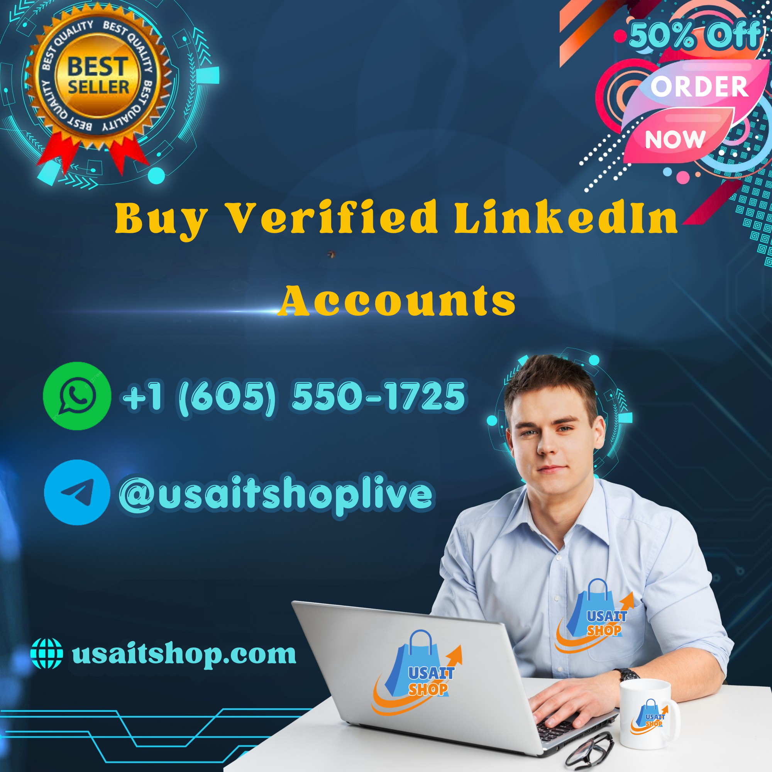
Buying “verified,” PVA, or aged LinkedIn accounts may look like a shortcut for businesses, recruiters, and marketers, but purchasing or transferring personal LinkedIn accounts carries substantial policy and security risks. LinkedIn’s current User Agreement requires members to use one account in their real name, keep their password secret, and not share or transfer their account or another person’s personal data.
For that reason, this guide does not recommend 25 account-selling websites. Instead, it explains safer alternatives for achieving the same business objectives without purchasing someone else’s LinkedIn identity.
If you want to more information just Contact us–
╚◉》WhatsApp: +1 (605) 550-1725
╚◉》Telegram: @usaitshoplive
╚◉》Email: usaitshop1@gmail.com

Why People Search for Aged or Verified Accounts
Aged accounts are often marketed as having an established history, while “PVA” accounts typically claim to have phone-number verification and “verified” accounts may be advertised as having completed additional identity or security checks.
However, an account's age or claimed verification does not guarantee that it is trustworthy, transferable, or safe for long-term use. LinkedIn explicitly prohibits creating false identities, using another person's account, sharing accounts, and transferring accounts.

25 Safer Alternatives to Buying LinkedIn Accounts

Account and Profile Management
- Create your own LinkedIn profile — Use your real identity and accurate professional information.
- Build your profile completely — Add legitimate experience, education, skills, and professional interests.
- Grow your network organically — Connect with people you genuinely know or professionally interact with.
- Publish useful professional content — Establish credibility through consistent, authentic contributions.
- Keep your profile information current — Regularly update employment and contact details.
- Use LinkedIn's security features — Protect your account with a strong, unique password and available security controls.
- Don't share login credentials — Employees and contractors should not need your personal password.
- Avoid fake identities — LinkedIn specifically prohibits fake profiles and misleading professional information.

Business and Recruiting Solutions
- Create a LinkedIn Page for your company — Build an official presence for your organization.
- Use legitimate employee profiles — Have employees represent themselves rather than operating purchased identities.
- Use LinkedIn Recruiter where appropriate — Choose an official recruiting solution for professional hiring activity.
- Use LinkedIn Sales Navigator — Build prospecting workflows around legitimate accounts.
- Use LinkedIn advertising — Promote a business through official advertising products.
- Establish an authentic company presence — Maintain accurate branding and organizational information.
- Use appropriate business permissions — Give team members access through supported business arrangements rather than sharing personal credentials.

Things to Avoid
- Avoid account marketplaces — A seller cannot guarantee permanent access to an account they do not legitimately own or control.
- Avoid “guaranteed safe” account claims — No third party can guarantee that LinkedIn will never restrict an account.
- Avoid fake verification claims — Verification should come through LinkedIn's own processes where available.
- Avoid accounts created with false identities — LinkedIn requires members to use their real names and accurate information.
- Avoid cookie or session transfers — LinkedIn expressly prohibits attempting to use another person's account, including through shared credentials or copied cookies.
- Avoid unauthorized automation — LinkedIn prohibits bots and other unauthorized automated methods that generate inauthentic activity.
- Avoid scraped member data — LinkedIn restricts the copying and distribution of member information without appropriate consent.
- Avoid services promising restriction bypasses — Attempting to circumvent LinkedIn's access controls can violate its rules.
- Avoid sharing one personal profile among multiple operators — LinkedIn says profiles should have one account owner and personal login information should not be shared.
- Use official LinkedIn products instead — When you need recruiting, sales, advertising, or company-management capabilities, use LinkedIn's legitimate business solutions.

What Does “PVA” Mean?
In account-selling terminology, PVA generally means “phone-verified account.” This describes a verification method claimed by sellers, not an assurance that the account is legitimate, compliant, or suitable for your business.
If you want to more information just Contact us–
╚◉》WhatsApp: +1 (605) 550-1725
╚◉》Telegram: @usaitshoplive
╚◉》Email: usaitshop1@gmail.com
A phone-verified account can still have an unknown history or violate LinkedIn's rules if it was created with false information or transferred between people.

Are Aged Accounts Safe?
Not necessarily. LinkedIn states that it may restrict, suspend, or terminate accounts when members breach its User Agreement or misuse the service.
An account being several months or years old therefore does not make it immune from enforcement. If the account was previously used for spam, automation, deceptive activity, or other policy violations, a new buyer could inherit those risks.

The Better Strategy
For businesses looking for an established LinkedIn presence, the sustainable approach is to build legitimate profiles, company Pages, professional connections, and business activity over time.
This provides a stronger foundation than purchasing an account with an unknown history and avoids problems associated with account ownership, identity, security, and platform enforcement.

Conclusion
There are many websites that advertise aged, PVA, or verified LinkedIn accounts, but a marketplace listing does not make an account transfer legitimate or safe. LinkedIn's current rules prohibit members from sharing or transferring accounts and prohibit fake identities and use of another person's account.
Instead of ranking account sellers, businesses should use authentic LinkedIn profiles and official business products for recruiting, sales, marketing, and professional networking. This approach is slower than purchasing an established account, but it provides considerably better long-term security and compliance.

